Agriculture in New Zealand
I was fortunate enough to be awarded the OH Club Travel Scholarship to aid my trip to New Zealand in the summer of 2025. Having grown up on the family pedigree Welsh Black beef farm in Herefordshire and currently at Harper Adams University studying to enter the land management industry, I wanted to be able to see and experience farming practices abroad before I do so.
New Zealand is well known for its extensive, low input agricultural systems with little to no subsidy funding and heavy reliance on export markets. With pressure on UK farming to become much less reliant on subsidies and more extensive in order to support environmental sustainability goals, New Zealand seemed like the ideal farming to experience to broaden my knowledge and help advise British farmers and land managers in the future.
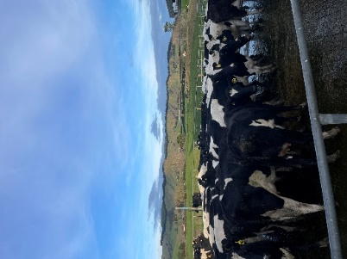
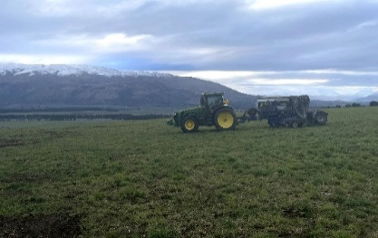
I was able to visit a total of six farms during my visit to New Zealand, all with different systems. The dairy industry was of particular interest to me due its contrast to UK dairy farming. In the UK milk contracts operate on a per litre payment basis whereas in New Zealand, it is based on the quality of milk that is produced. This payment style is heavily responsible for the herd characteristics such as using Jersey cattle much more than we do in the UK to increase the milk solids content. This means a smaller animal as opposed to our standard Friesian / Holstien thus requiring lower inputs. New Zealand dairy farms also have significantly less farm buildings with cows grazed outside all year around. Generally, the only infrastructure is the parlour and a calf rearing shed – this reduced infrastructure increases grazing available and significantly reduces the ‘locked up carbon’ in a farming unit.
I was also able to spend time on a number of farms in the Otago region of South Island. This is a heavily irrigated area that, prior to irrigation, was unproductive. Now this area is incredibly agriculturally diverse with, merino sheep, vineyards, soft fruit production and dairy wintering taking place. This area was a stark highlight of agriculture’s reliance on finite resources such as water, particularly in areas where irrigated productive land was adjacent to natural roughage ground.
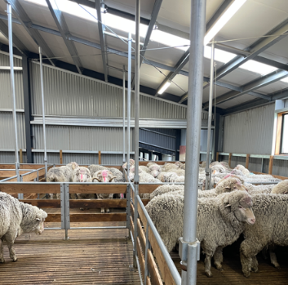
New Zealand also seemed to be much more efficient with their land use in terms of what kind of land they deemed ‘farmable’. With such mountainous terrain, the livestock systems were set up in such a way to best use the landscape. Dairy heifers were often sent to be reared on land that would not be suitable for milking cows in order to preserve the better ground for productive animals.
A much more relaxed approach was also taken to the control of disease spreading pests such as possums and wallabies. These two animals are the main spreaders of TB in New Zealand and unlike badgers in the UK that play the same role, there was no controls on the shooting / trapping of the species meaning they had much lower testing requirements on the livestock. New Zealand also had a much more pragmatic approach to the efficient use of resources such as water. On every farm I visited, without fail, there was extensive water storage infrastructure in place meaning they could operate without the need for mains water if required with extensive piping and pumps to move the water where necessary. This is a principle that would enhance the risk resilience of many UK farms.
My time in New Zealand was an eye opener to low input, extensive and profitable farming systems with efficient resource management. Many of the techniques used to achieve these principles are transferrable to the UK and I will try to implement them where suitable to help my clients in the future.
I would like to thank the OH Club for supporting me to undertake this travel to research transferable agricultural practices to aid me in my final of year of university and to help future clients to adopt new systems in the UK.

